Nicholas Marshall

Dr. Nelbert St. Clair

ITEC 4344 – Ethical Hacking

September 16, 2018

Lab 4a – Hack into your Wi-Fi

We were tasked in this lab with hacking into our own Wi-Fi. The tool that I used was **Aircrack-ng**. First thing that is needed to be done is to kill the Wi-Fi process. Then you would want to reboot the wlan0 in monitor mode by using airmon-ng start wlan0. Also, we will want a txt file with a big pool of passwords (9.8 million different keys).

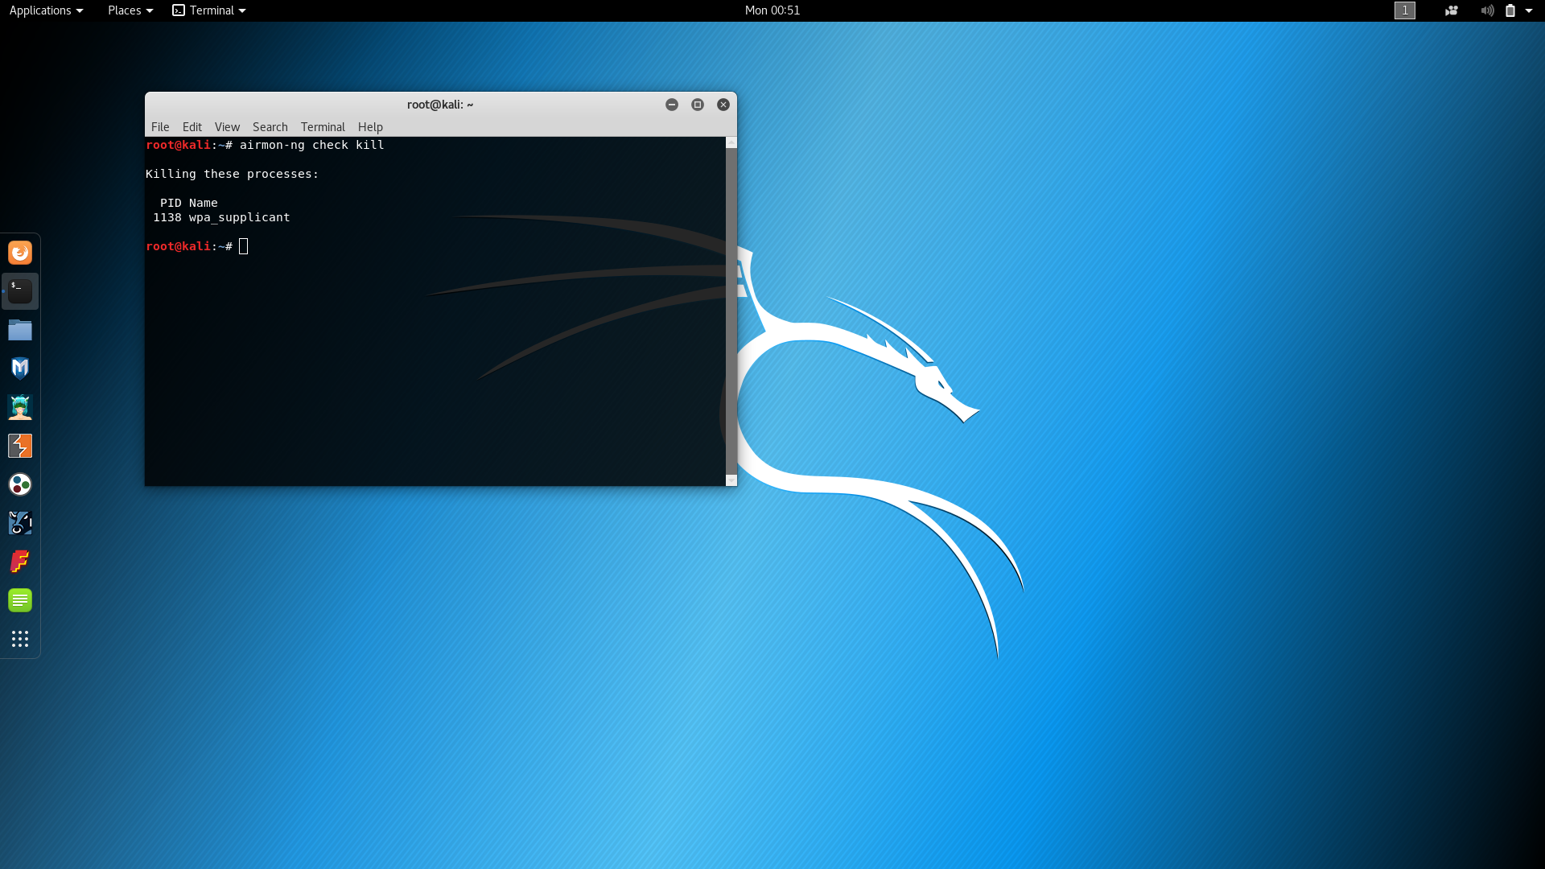

From this point we will need to scan the network we are monitoring to try to catch the STATION MAC address since it did not work on the target I used it’s BSSID so, we will be able to momentarily deauthorize the user. This allows use to capture the WPA 3-way handshake. Once we then get the handshake we will then be able to aircrack the password by giving the txt file to search through while giving the hack-01.cap file we created with the handshake.

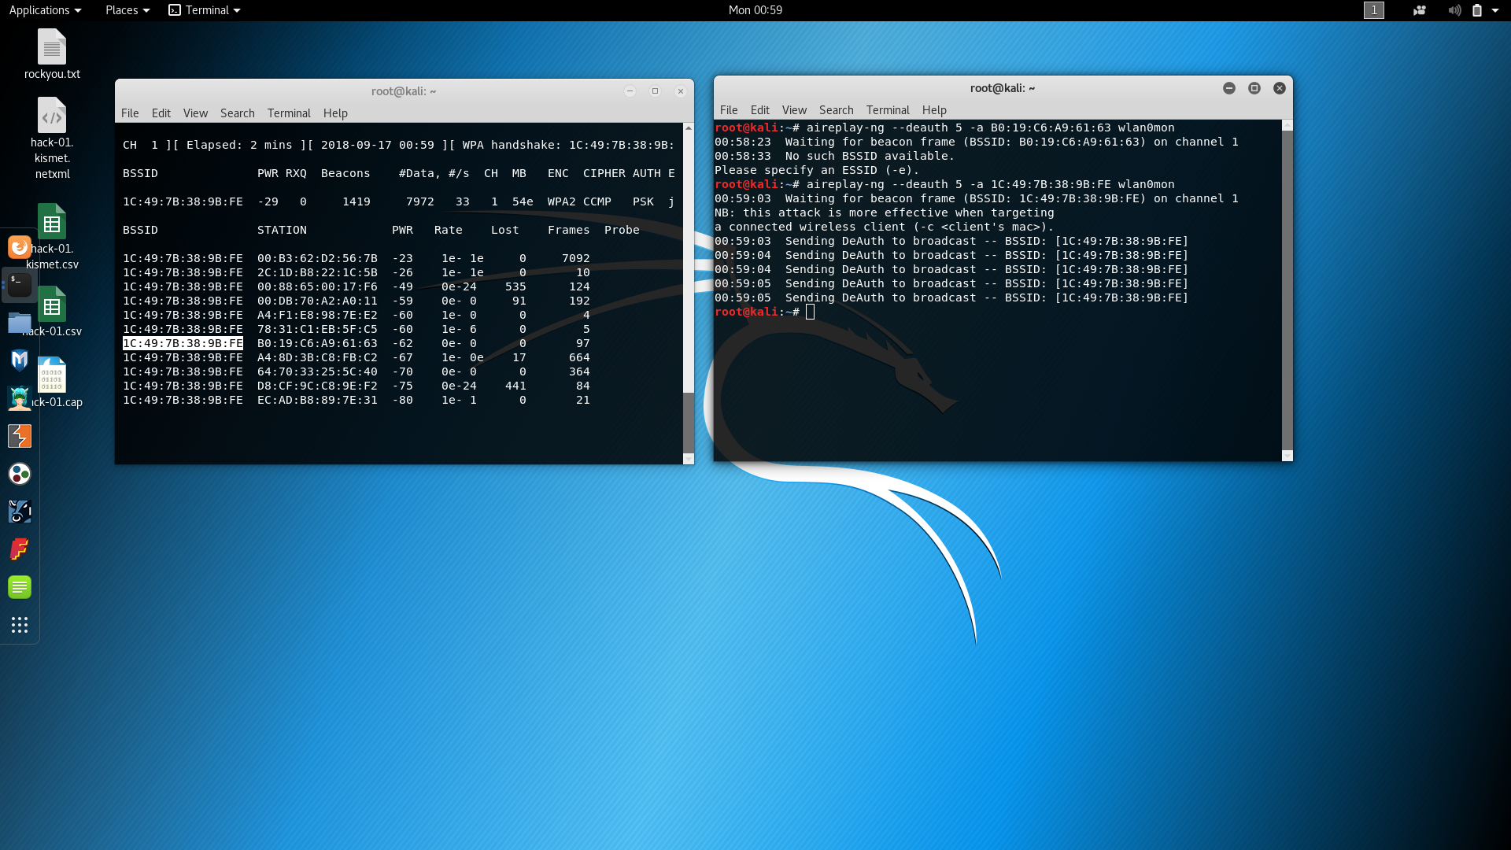

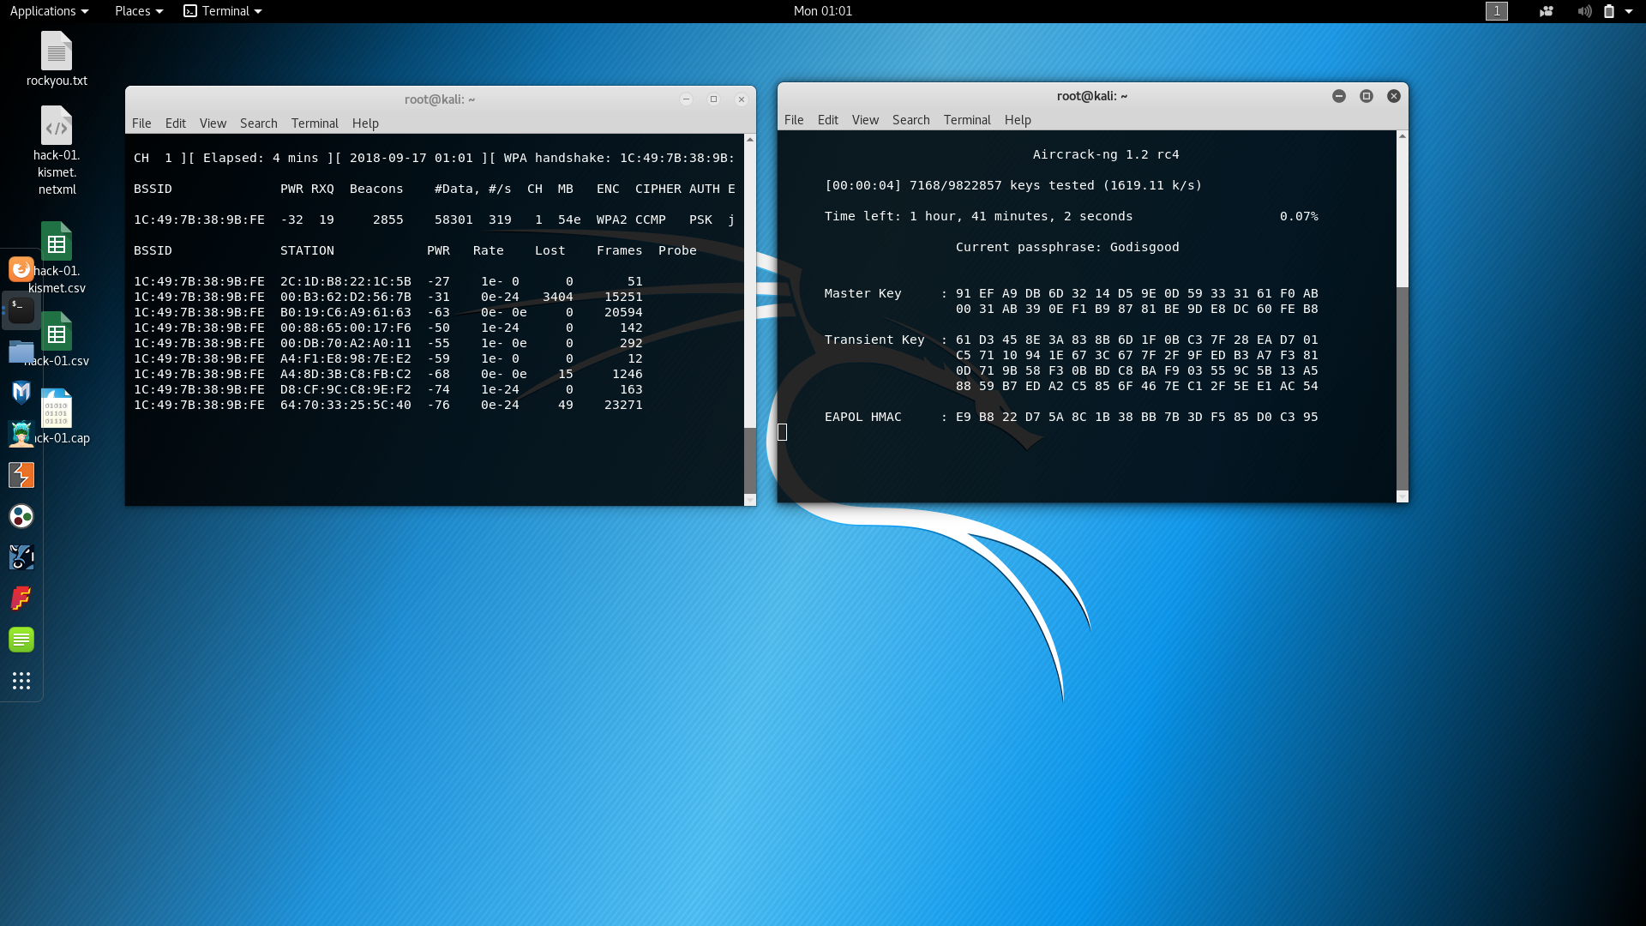

Now that we have specified the txt file to use for keys, capture file, and the BSSID to use Aircrack-ng to translate for the Master Key.

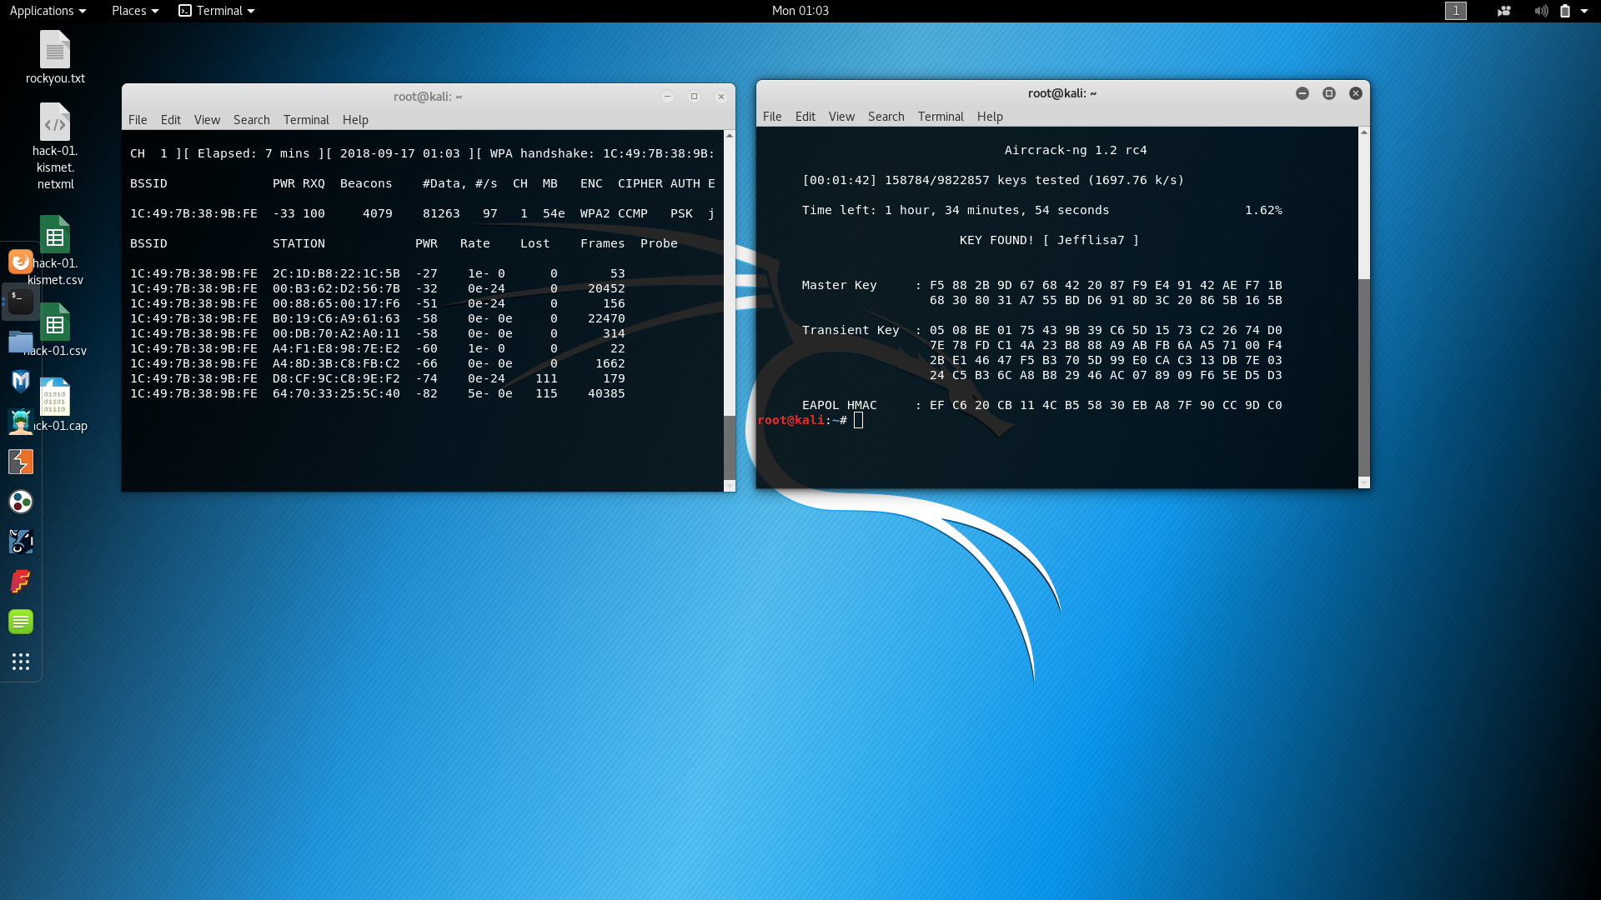

Finally, after several thousand key searches we happened to find the Master Key that allows us to gain access to the Wi-Fi.

This was the only tool that I used along with the only way that I attempted to hack my Wi-Fi. I will now be changing the password to the router since I have cracked it and you have seen the password.